MYPOKER
TOURNAMENT
USER MANUAL
Tournament setup • Scenario management • Clock • Payouts • Sounds
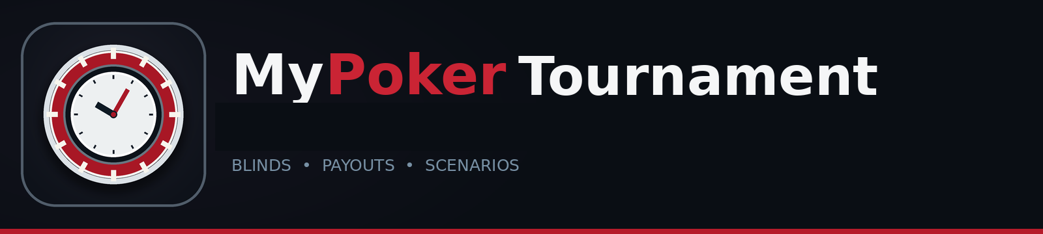
User Manual v1.2.0
Help button in the black header immediately left of Save
Important release note
This release is intended to be installed with MyPokerTournament-Setup-1.2.0.exe. The installer includes the application, offline Help, user manuals, icon, and bundled sounds. Python does not need to be installed separately. The installer targets 64-bit Windows (x64-compatible).

Prepared for offline use at the tournament table and TV display.

Contents
Use this guide alongside the Help / User Guide button in the black header immediately to the left of Save. Press F1 on a main tab to open the related help topic.
1. Quick start Prepare and start a tournament
2. Main interface What each tab is for
3. Scenario Manager Create, save, duplicate, and launch setups
4. Tournament Settings Types, fees, Benefit Pot, and payout method
5. Players and entries Keep active players separate from paid entries
6. Blind Structure Manage levels, durations, breaks, and imports
7. Clock and full-screen display Timer adjustments, transitions, and TV controls
8. Payout Calculator Traditional, mixed, and freeroll payouts
9. Mixed payouts and freeroll Fixed awards, percentages, rounding, and fallback
10. Charity and fees Benefit Pot, Home Game house fee, and re-entry proceeds
11. Display and sounds Monitor sizing, gong, warning tone, and custom WAV files
12. Reports and data protection Exports, files, and backups
13. Help and troubleshooting Offline help, common issues, limitations
Recommended workflow
Configure the tournament type and rules, verify the blind schedule, confirm payout settings, enter the counts, then start the clock. For a repeat event, create or select a saved scenario before game night.

1. Quick Start
A practical checklist for setting up a new tournament.

Before the event
1. Download and run MyPokerTournament-Setup-1.2.0.exe, then follow the Windows installer.
2. Choose whether to create an optional desktop shortcut; the installer creates a Start Menu shortcut automatically.
3. Launch MyPoker Tournament from the Start Menu or optional desktop shortcut.
4. Open Tournament Settings and choose the tournament type: Standard Tournament, Charity Tournament, Home Game, or Freeroll.
5. Review Entries & Fees, the Tournament Type tab when it is available, and Payout Rules. Confirm the blind schedule; blind levels advance automatically and each break has its own Pause? setting.
6. Open Blind Structure and confirm every play level and break. Use import or bulk durations if needed.
7. Click Save in the upper-right corner.
8. Use the quick tournament count controls on the Tournament Clock page to add initial entries and verify active-player, entry, rebuy, and add-on counts.
9. Open Tournament Clock. Start the clock and open Full Screen Display for the TV.
Strongly recommended
Before a live event, test one clock transition, one 60-second warning, the blind-start gong, one rebuy, one bust, and one payout calculation. Keep a backup of your saved JSON data files.

2. Main Interface
The top-right Save button applies and saves the visible settings. Use the main tabs to move between tasks.

Example Tournament Clock page with current-level timer, slider, quick controls, status, statistics, and payout summary. Values are illustrative.
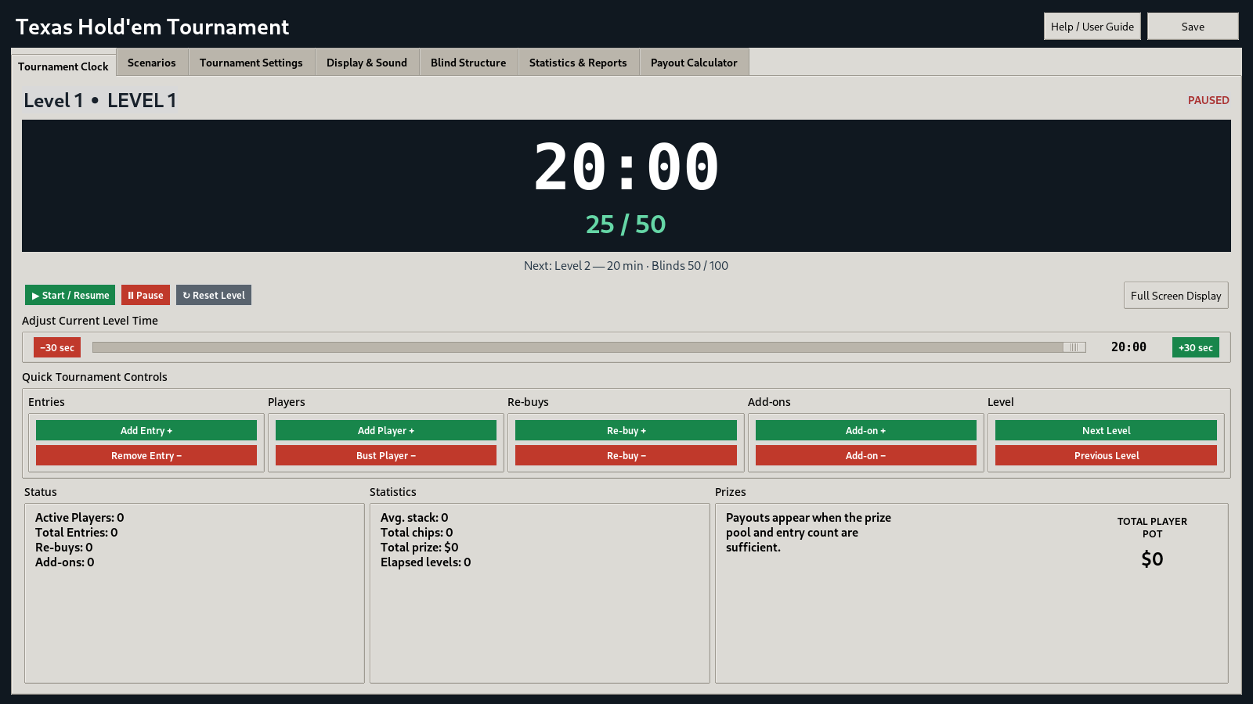
Tab | Use it for
Tournament Clock | Start/pause/reset the clock, adjust remaining time, view the current and next level, and open the full-screen TV display.
Scenarios | Build and manage reusable tournament setups; launch a fresh session from a scenario.
Tournament Settings | Set tournament type, fees, rebuys, add-ons, Benefit Pot, payout mode, and payout rules. Configure pausing per break in Blind Structure.
Display & Sound | Adjust main window size, live-preview full-screen control font/button sizing, and configure sound events.
Blind Structure | Edit/import the sequence of blind levels and breaks.
Quick count controls | Use the quick count controls on Tournament Clock to adjust active players, initial entries, rebuys, and add-ons.
Statistics & Reports | Review and export reports.
Payout Calculator | Review the calculated payout list and active payout mode.
Help / User Guide | Open the offline Help window, search topics, use Quick Start, or launch the PDF manual.

3. Scenario Manager
A scenario stores reusable setup rules, not the live player counts or results.

Scenario Manager ready to create, save, or launch reusable scenario definitions.
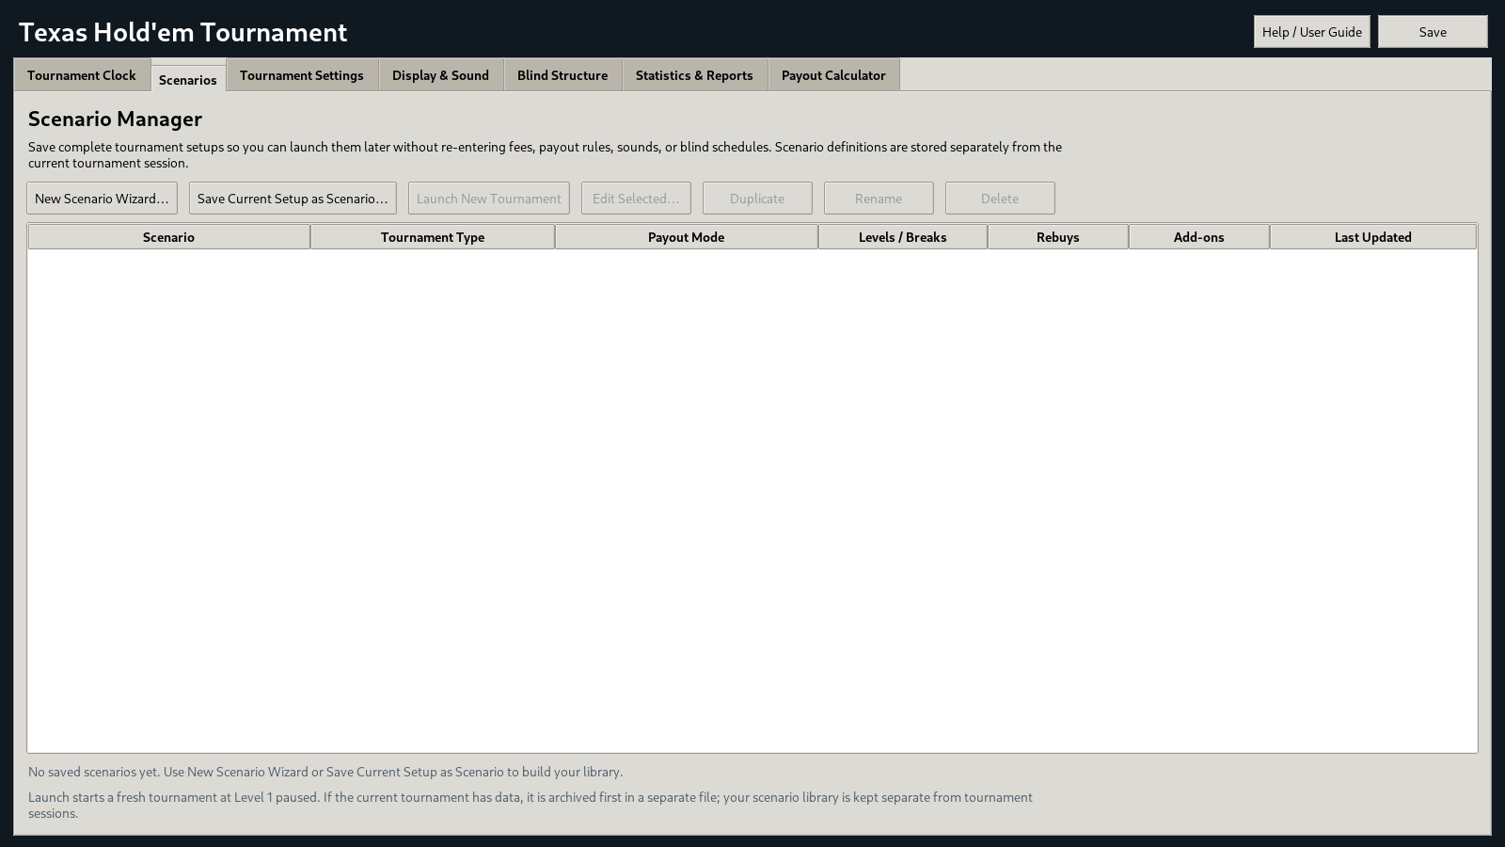

Create a scenario
1. Choose New Scenario Wizard to start a new setup, or Save Current Setup as Scenario to capture the current configuration.
2. Step 1 — Scenario Basics: enter the scenario name, display title, type, description, and starting blind structure.
3. Step 2 — Entries & Rules: set starting stack, buy-in, re-entry fee, Home Game house fee, add-on fee/chips, and enabled options. Set individual break pause behavior in Step 4.
4. Step 3 — Charity & Payouts: configure Benefit Pot settings, payout mode, paid-place rule, rounding, percentage splits, mixed payouts, or fixed freeroll awards.
5. Step 4 — Blind Structure & Review: use the current structure, a starter structure, or another scenario; review and save.

Manage and launch
Select a scenario to Edit, Duplicate, Rename, Delete, or Launch New Tournament. Double-clicking a selected row also launches it. Use clear names such as “Standard Rebuy 20-Minute”, “Turbo 10-Minute”, or “Charity Freeroll”.
Launch safety
Launching a scenario starts at Level 1, paused, with fresh entry/player counts. If the current tournament contains data, the app archives the current session first. If it cannot create the archive, the launch is blocked instead of discarding the session.

4. Tournament Settings
Select a tournament type as the starting template, then review each settings sub-tab.

General settings: type, tournament display name, and starting stack.
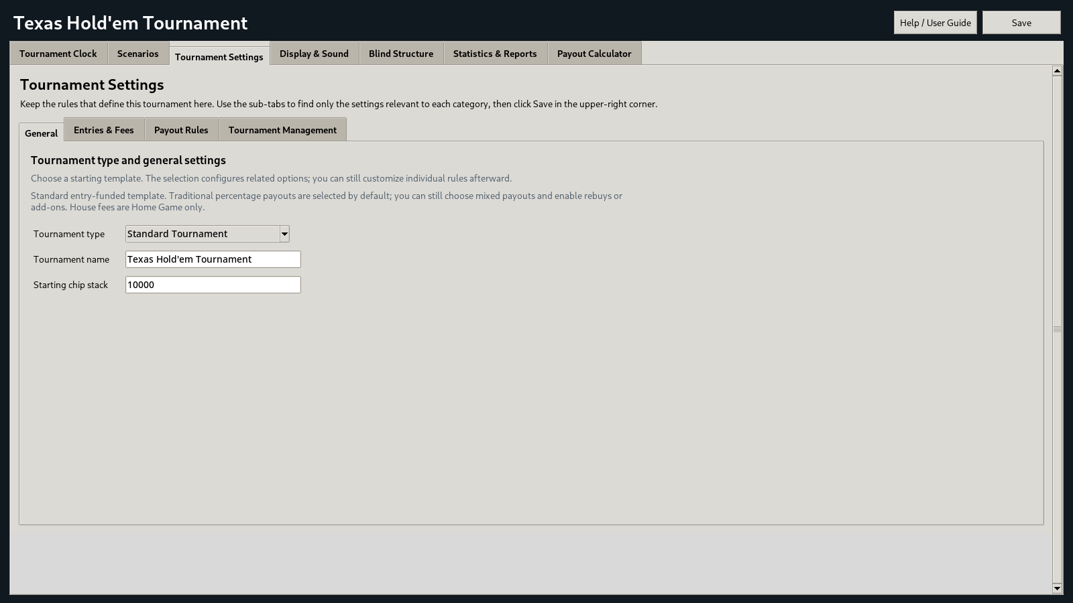
Sub-tab | Key settings
General | Tournament type, display title, starting chip stack.
Entries & Fees | Buy-in, re-entry fee, Home Game house fee, add-on fee/chips, and switches for rebuys and add-ons.
Tournament Type | Shown for specialized formats. Configure Benefit Pot for Charity, the Home Game house fee, and other type-specific settings.
Payout Rules | Payout mode, rounding, paid-position rules, thresholds, traditional splits, mixed payouts, and freeroll prizes.
Tournament Management | Reset Tournament to Zero and other administrative actions.

Tournament type templates
Standard Tournament: A normal entry-funded starting template. Rebuys and add-ons can be enabled individually. The Benefit Pot is optional.
Charity Tournament: Starts with the Benefit Pot enabled. You can combine charity with traditional, mixed, or freeroll payout settings.
Home Game: Supports a house fee. House Fee is available and applied only for this type.
Freeroll: Sets the initial buy-in and house fee to zero and selects fixed freeroll prizes by default. Paid re-entries/add-ons and the Benefit Pot remain optional.
Dependency behavior
Fields may be greyed out because they do not apply. For example, House Fee is disabled for Standard, Charity, and Freeroll. Disabled rebuys/add-ons hide their live controls and are excluded from their relevant totals.

5. Players and Entries
This release uses count-based tracking. The active player count is intentionally separate from paid entries and rebuys.
Control | What it changes
Add Player + | Increases active players only, up to the total-entry limit. Use it to restore a player after an accidental bust.
Bust Player − | Decreases active players. It does not delete a paid entry.
Add Entry + | Adds an initial entry and increases active players.
Remove Entry − | Removes one initial-entry count. Review the active-player count afterward and adjust it separately if needed.
Re-buy + / − | Changes rebuy count and paid-entry total. It does not automatically change active players.
Add-on + / − | Changes add-on count only. It does not change players or paid-entry thresholds.
Reset Tournament to Zero | Clears current tournament counts/activity after confirmation. Use only when intentionally starting over outside the scenario launch flow.

Keep these counts distinct
Active Players means players still in the tournament. Total Entries means initial entries plus rebuys. Rebuys are tracked separately. Add-ons are tracked separately and are not paid-entry positions.

Useful checks
- Before starting, confirm the initial-entry total and active-player count match your intended opening field.
- After a bust, use Bust Player −; total entries should remain unchanged.
- After a rebuy, confirm Re-buys and Total Entries change while Active Players remains unchanged; use Add Player + if you need to restore an active count after a bust/re-entry.
- Add-on controls are visible only while add-ons are enabled. Re-buy controls are visible only while rebuys are enabled.

6. Blind Structure and Breaks
The level table defines the order and duration of every play level and break.

Edit a schedule
1. Use Add Level or Edit Selected to set a play-level name, duration in minutes, small blind, and big blind.
2. Use Add Break to insert a break row and set its duration/name.
3. Reorder rows so levels and breaks occur in the intended sequence. Confirm the next-level preview after edits.
4. Use Apply to All Play Levels to set a shared duration for all play levels, and Apply to All Breaks for all break rows.
5. Click Save after finishing the schedule. Replacing the blind structure through import resets the clock to Level 1.

Import a blind structure
Select Import Blind Structure and choose a supported file. CSV, TSV, TXT, and XLSX are supported. For XLSX files with multiple populated worksheets, select the worksheet to import. Choose whether to replace the current structure or append rows, then review the result in the level table.
Ante fields are hidden in this release
The current release does not expose ante settings or ante columns. Existing legacy ante data may remain in saved files but is not active in the interface or calculations.

7. Clock and Full-Screen Display
Use the same clock controls on the main page or in the full-screen TV display.

Full-screen display with current and next blind values, digital clock, time-remaining pie chart, and mouse controls. The remaining slice turns yellow below 60 seconds and red at 20 seconds or less.
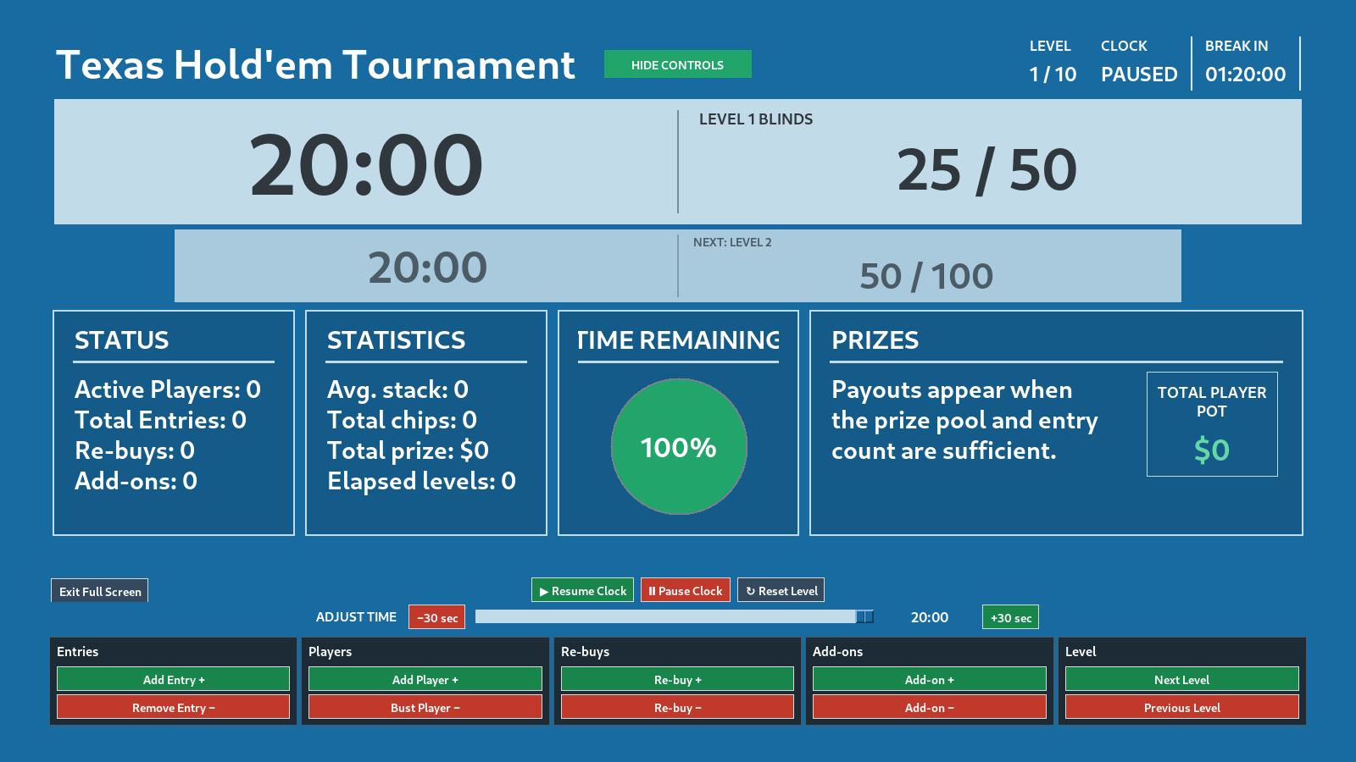

Clock controls
Control | Behavior
Start / Resume | Starts the current level or continues it after a pause.
Pause | Stops the countdown without changing the remaining time.
Reset Level | Returns the current level to its full scheduled duration.
Time slider | Adjusts remaining time from 0 to the current row’s configured duration.
−30 sec / +30 sec | Adjusts remaining time in 30-second steps, clamped between 0 and the current level’s maximum.

Automatic transitions and breaks
Blind levels always advance automatically when their timer reaches zero. For breaks, the individual Pause? checkbox on that break row determines whether the clock waits paused before continuing. If unchecked, the next row starts automatically. Normal transitions do not require you to dismiss a popup.

TV display tips
- Use the full-screen display for the TV and the main window for detailed controls and configuration.
- Hide Controls gives players a cleaner view; Show Controls restores the buttons with the mouse. Dashboard positions stay fixed.
- Time Remaining is a percentage of the current level/break, not the entire tournament. The digital clock remains the exact time display.
- The header shows the time until the next break, or the break ending time if a break is active.
- Press Escape to exit the full-screen display.

8. Payout Calculator and Payout Modes
Payout method and configuration are managed under Tournament Settings → Payout Rules. Payout Calculator is the results view.
Mode | Use when | Key behavior
Traditional Percentages | The prize pool is distributed by a saved percentage split. | The percentages for a place count must total 100%. Default entry thresholds determine paid places unless changed.
Mixed Fixed + Percentage | One or more positions need fixed dollar awards while others use percentages. | Fixed awards are deducted first. Percentage rows share the remaining pool and must total 100%.
Freeroll Fixed Prizes | The host funds fixed awards for 1–3 places. | Fixed dollar amounts do not expand or shrink with entry count.

Paid-position rules
Automatic by entry rules: Use the entry thresholds and the paid-place count assigned to the matching range. Rebuys count as additional paid entries.
Target fixed number: Target a chosen number of paid positions, limited by the actual number of entries.
Automatic with maximum cap: Use the thresholds but never exceed the selected maximum.
When the charity maximum cap is enabled, it is an additional restriction on paid places. Freeroll fixed prizes use the configured fixed award positions rather than entry thresholds.

9. Mixed Payouts and Freeroll Fixed Prizes
Verify the payout summary before announcing awards.

Mixed payout example
For a $1,000 pool with sixth place fixed at $50, the $50 fixed award is deducted first. The first five places share the remaining $950 according to their configured percentages. The example illustrates the calculation order; actual awards depend on the saved percentages and rounding rule.
Place | Payout method | Calculation base
1st–5th | Percentage (percentages total 100%) | Share the pool remaining after fixed amounts are deducted
6th | Fixed amount: $50 | Paid as entered

Safety fallback
After rounding and reconciling the total, the app checks that every award is positive and that each higher position pays at least as much as any fixed award assigned to a lower position. If the mixed structure is invalid or violates that rule, the calculation falls back to the traditional percentage split for that payout calculation and displays the reason. The saved mixed setup remains available to edit.

Configure fixed freeroll awards
1. Select Freeroll Fixed Prizes under Tournament Settings → Payout Rules.
2. Choose Configure Freeroll Prizes and select one, two, or three paid places.
3. Enter a positive whole-dollar amount for every enabled place and save.
4. The awards remain fixed regardless of the number of recorded entries. Charity/Benefit Pot, paid re-entries, and add-ons can be configured separately.
Before paying prizes
Confirm the active payout mode, paid-place count, Total Player Pot, any Benefit Pot, and every displayed dollar award. Mixed fallback notices must be reviewed before the tournament concludes.

10. Charity, Benefit Pot, and Fees
Charity is an independent setting and can be combined with any payout mode, including Freeroll Fixed Prizes.

Benefit Pot
In Tournament Settings → Charity / Benefit Pot, enable the Benefit Pot, choose Fixed per entry or Percentage of each entry, and set the amount or percentage. The Benefit Pot is shown immediately above Total Player Pot when the calculated benefit amount is greater than zero; otherwise that line is hidden.

House fee
House Fee is available only when Tournament Type is Home Game. For Standard, Charity, and Freeroll templates, the field is disabled and the effective house fee is zero. The Home Game fee is retained when switching templates so it can be restored if Home Game is selected again.

Re-entry fee allocation and fixed pots
The current application calculates the entry-funded pool from the configured buy-in, paid re-entry fees, add-on fees, house fee where enabled, and Benefit Pot settings. Freeroll fixed prizes are host-funded awards. Inspect the Payout Calculator before paying prizes, especially when combining Charity with Freeroll or a mixed payout structure. The Statistics & Reports tab is hidden in v1.2.0; its underlying code is retained for possible future use.
Naming
The user-facing label for the charity allocation is Benefit Pot. “Total Player Pot” refers to the calculated player prize pool shown beside the payout list.

11. Display and Sound
Tune the main window for your monitor and configure event audio.

Window size
Open Display & Sound → Configure Window Size. Set the main window width and height independently from 70% to 100% of the monitor’s reported dimensions. Preview before saving. The window is centered, and this setting does not resize the full-screen TV display.

Full-screen control appearance
Open Display & Sound → Configure Full-Screen Controls. This opens the actual full-screen tournament display with a floating settings dialog. Adjust the Control font size (8–15 pt) and Button size (75–150%) sliders; the visible button labels, headings, padding, and Timer Beacon tab update as you move the sliders. Drag the dialog by its title bar if it covers a part of the display you want to inspect. Save & Finish stores the values and leaves the display open for a final look. Press Esc afterward to return to the main application. Cancel Preview discards changes, restores the previous sizes, and closes the preview. These settings apply to both Classic and Modern themes; dashboard text sizing remains separate. On the Modern theme, the dashboard cards, timer pie and text automatically scale down when larger control fonts and button sizes reduce available height, helping keep the Status and payout positions visible; Classic retains its existing layout behavior.

Sound settings
1. Open Display & Sound → Open Sound Settings.
2. Choose the default sound, set volume, and configure the low-time warning threshold. A threshold of 0 disables the warning.
3. Choose an override for individual events or leave Use default. Use Test to preview each event sound before saving.
4. Long Gong.wav is the supplied blind-start gong. One Minute.wav is the supplied low-time warning.
5. Custom sounds must be uncompressed PCM WAV. The installer includes the bundled WAV files. Do not remove files from the installation folder. Custom WAV files can be selected by full path in Sound Settings.
Verify audio on the actual computer
Sound routing, Windows volume/mixer settings, and output device selection can affect playback. Always test the gong and low-time warning on the computer connected to the tournament display.

12. Reports, Saved Data, and Backups
Keep the current tournament, scenario library, and archived sessions protected as separate files.

Reports and exports
The Statistics & Reports tab is hidden from the main navigation in v1.2.0; its underlying code is retained for possible future use. Blind Structure can be exported to CSV. Payout Calculator shows the current estimated payout rows, payout methods/shares, and award values. Recalculate after changing counts or payout/fee settings.

Data files
File | What it stores
mypoker_tournament.json | Current tournament state, counts, timer, levels, and configuration.
mypoker_tournament_scenarios.json | Reusable scenario definitions, separate from the current tournament.
mypoker_tournament_sessions.json | Session archives made before launching a scenario over an existing tournament.

These files are located in the current Windows user’s home folder. Close the application before copying them for backup. To preserve the whole setup, back up all three files together. Do not hand-edit the JSON files while the app is running.

Launch safety
Scenario launch archives the current tournament first if there is session data. If the archive cannot be written, the app blocks the launch rather than replacing the live session. A dedicated archive browser/restore screen is not included in this release, so keep manual backups of the archive file.

13. Built-in Help and Troubleshooting
The Help / User Guide button in the black header immediately to the left of Save opens the built-in Help window, which works offline. The PDF manual is bundled alongside the application. This button is in the main application header and is intentionally not shown on the dedicated full-screen TV display.

Help / User Guide window: search topics, open Quick Start, or launch this PDF manual.
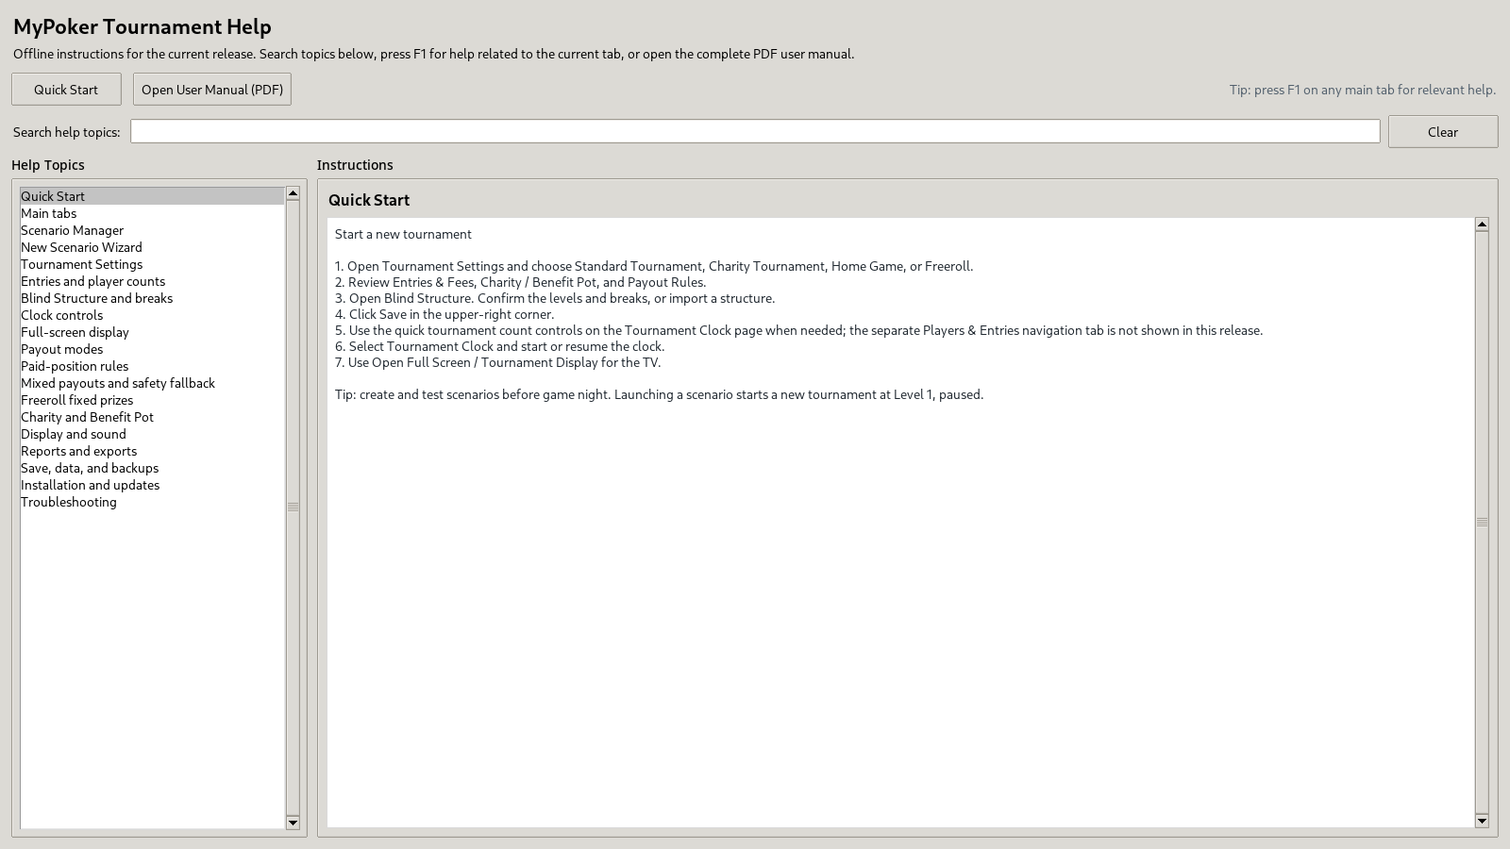

Built-in Help
1. Click Help / User Guide in the black header immediately to the left of Save, then select a topic from the left-hand list.
2. Use Search help topics to filter by a word such as “rebuy”, “payout”, “break”, or “sound”.
3. Click Quick Start for the initial workflow, or Open User Manual (PDF) to open the full guide in your default PDF reader.
4. Press F1 on a main tab to open help for that section.

Troubleshooting checklist
Problem | What to check
App does not start | Launch MyPoker Tournament from the Start Menu or desktop shortcut. If it fails, try reinstalling with MyPokerTournament-Setup-1.2.0.exe. Back up all three JSON data files before reinstalling.
Gong or warning is silent | Open Sound Settings, confirm sound is enabled and volume > 0, use Test, check Windows audio output, and make sure WAV files are present.
Controls are greyed out | The selected tournament type or payout mode may not use that control. Review Tournament Settings and enabled options.
Mixed payout falls back | Read the displayed reason. Check that percentages total 100%, fixed awards leave enough pool, rounding yields positive amounts, and higher places satisfy the minimum-payout rule.
TV cuts off main window | Lower width/height percentages under Display & Sound → Configure Window Size. Full-screen display uses a separate layout.
Scenario launch blocked | Check disk space and that the session archive file is writable and valid. Back up data files before attempting repairs.

